TCN4211
Telecommunication Networks

Lab Number 3
Title Configure VLAN and Inter VLAN Routing

Author Name: Anaisy Garcia PID: 5734454

Sep 27



Florida International University

OBJECTIVES:
The objective in this lab is understanding how to configure a switch and router to connect two VlANs together for the transfer of data between them. Other objectives are understanding how to configure a VLAN within a switch, route the VLAN on a router, and create trunks to allow for simultaneous traffic transfer.
EQUIPMENT and COMPONENTS USED
For this lab the equipment used was:
- Laptop
- Cisco Packet Tracer Program
  - Within the Cisco Program, the components used were three generic pcs, a switch, and a router connected with copper straight-through cables.

EXPERIMENTAL METHOD AND PROCEDURE
Procedures:
- Set up the topology using three generic pcs, a switch, and a router with two different VLAN zones.
- Within the switch CLI (config), rename the switches to VLAN-A and VLAN-B using commands “vlan 2”, “name VLAN-A“, “vlan 3”, and “name VLAN-B”.
- Check within switch CLI to check both VLANs are active using command “show vlan”.
- Within the switch CLI (config), assign ports for VLAN-A on the switch using the commands “interface fastEthernet 0/2”, “switchport mode access”, and “switchport access vlan 2”. Repeat for other ports as well.
- Within the switch(config), assign ports using range for VLAN-B on the switch using the commands “interface range fastEthernet 0/3-4”, “switchport mode access”, and “switchport access vlan 3” in that order.
- Check within switch CLI (config) to check all ports are connected to correct VLANs using command “do sh vlan”.
- Within the switch CLI (config), enable trunk mode using the commands “interface fastEthernet 0/1” and “switchport mode trunk”.
- Within router CLI (config), assign an IP address and subnet mask to the router using commands “interface fastEthernet 0/0”, “ip address 192.168.10.1 255.255.255.248”, and “no shutdown”.
- Within router CLI (config), create a virtual sub-interface for each VLAN and assign different IP addresses to each VLAN using commands “interface fastEthernet 0/0.2”, “encapsulation dot1Q 2”, and “ip address 192.168.10.9 255.255.255.248”. Repeat for other VLANs.
- Within router CLI (config), check all sub-interfaces are up using command “do sh ip int bri”.
- Ping from a PC in VLAN-A a PC in VLAN-B to make sure a successful connection was made.
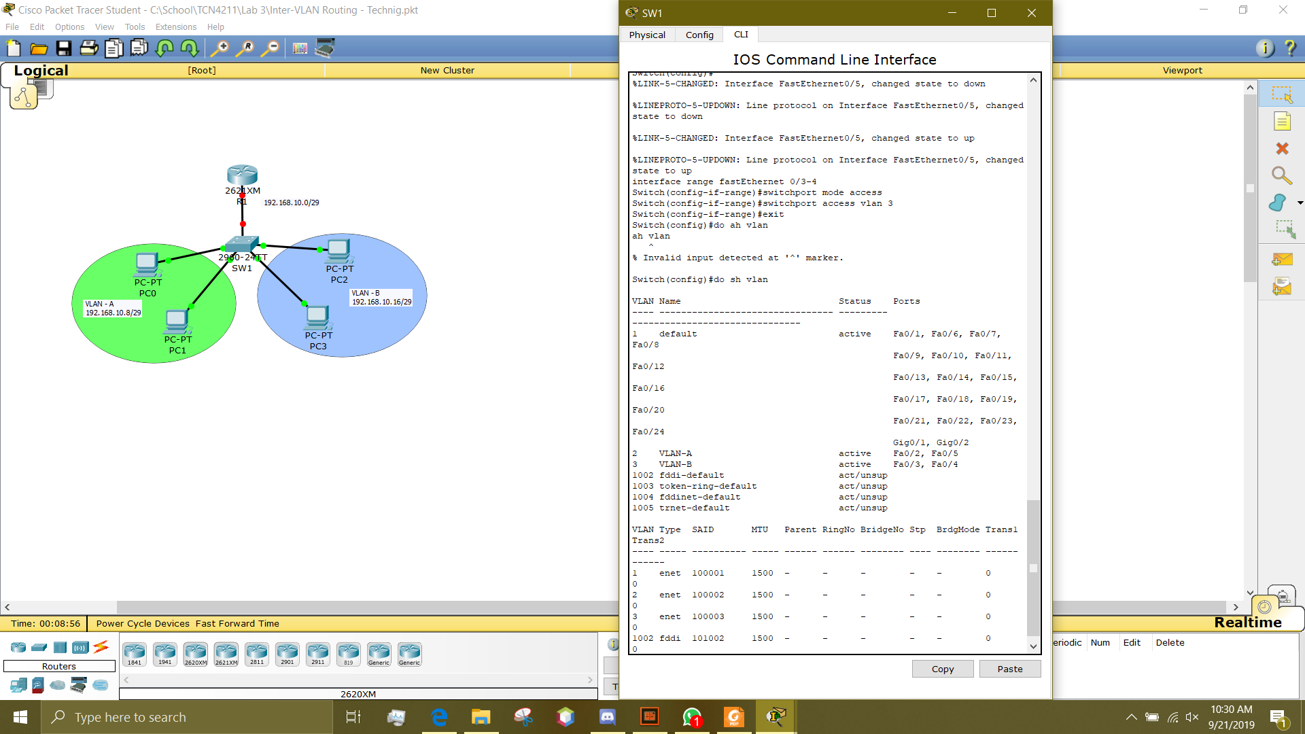
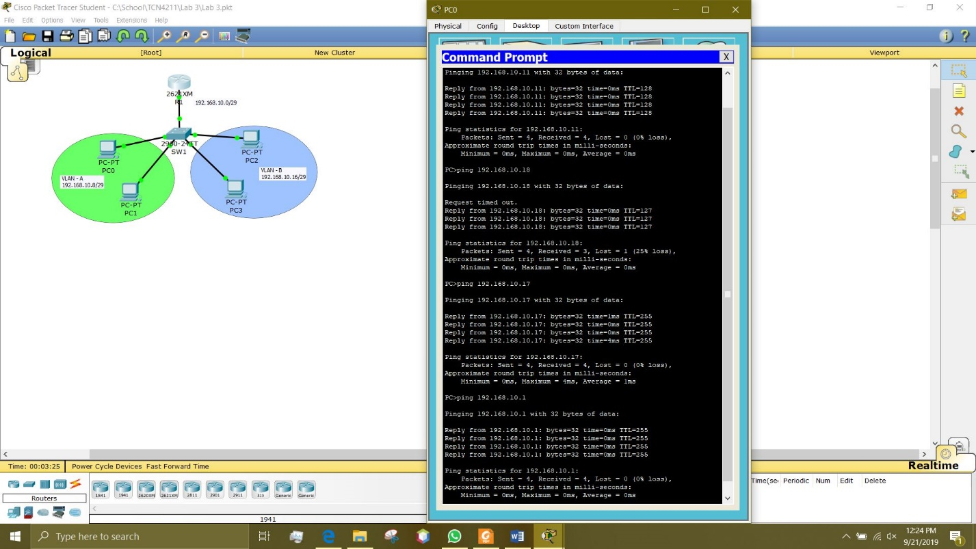
PC1
PC2
PC3
Router

PROBLEMS/QUESTIONS
Step 2: From PC0, ping PC1; was the ping successful? Now from PC0 ping PC2 and then PC3, was any of the pings successful? Explain why.
The ping from PC0 to PC1 was successful because they are on the same VLAN, within the same VLAN they can communicate without difficulty. The ping from PC0 to PC2 and PC3 however was not successful because they are on a separate VLANs. Without setting both VLANs up through the router, the communication between them is not possible.

Step 4: From PC0 ping PC2 and then PC3, was any of the pings successful? Explain why.
After setting up virtual sub-interfaces for each VLAN in the router, the ping from PC0 to PC2 and PC3 was successful because they are communicating through separate IP addresses within the router. This creates static IP addresses of the network and allows for the three networks to communicate successfully.

RECOMMENDATIONS and CONCLUSIONS
This lab it’s discovered how VLANs and routers work. In this lab, there were two different VLANs and two PCs on each VLAN. The two computers on the same VLAN could communicate with each other but those on other VLANs could not communicate with them and vise versa. To successfully communicate the two VLANs, the switch and router were set up. The router was the most important portion because it created static IP addresses within the network and router. Even though at the end the two VLANs were able to communicate some information was lost in the first ping for communication. For example, in the first ping from PC0 to PC2 (from above pictures) the first request timed out and that packet was lost. Later this was fixed due to having established a successful connection with the VLAN.

